AI DRIVEN INSIGHTS: EVALUATING MACHINE LEARNING TECHNIQUES FOR DIABETES DISEASE PREDICTION

Abstract
Diabetes mellitus is a rapidly growing chronic disease that poses serious health and economic challenges worldwide, emphasizing the need for early and accurate prediction systems. This project, titled “AI-Driven Insights: Evaluating Machine Learning Techniques for Diabetes Disease Prediction,” explores the effectiveness of various machine learning algorithms in identifying diabetes risk using clinical and demographic data. The study involves data preprocessing, feature analysis, and model training using supervised learning techniques such as Decision Tree, Support Vector Machine, Random Forest, AdaBoost, and XGBoost. Performance evaluation is conducted using standard metrics including accuracy, precision, recall, F1-score, and ROC-AUC to ensure reliable comparison among models. In addition to prediction, the system provides AI-driven insights by estimating risk levels and presenting confidence scores to enhance interpretability and clinical relevance. The experimental results demonstrate that ensemble-based models outperform traditional classifiers in terms of robustness and prediction accuracy. The proposed approach highlights the potential of artificial intelligence in supporting early diagnosis, personalized healthcare recommendations, and data-driven decision-making for diabetes management.

Keywords:
Diabetes Prediction, Artificial Intelligence, Machine Learning, Ensemble Learning, Random Forest, XGBoost, Clinical Decision Support, Risk Assessment, Predictive Analytics

CHAPTER I
INTRODUCTION
1.1 Objective of the Project
Problem Statement
Diabetes Mellitus is a chronic metabolic disorder characterized by prolonged hyperglycemia caused by insufficient insulin production, improper insulin utilization, or both. According to global health statistics, diabetes has emerged as one of the leading causes of morbidity and mortality, particularly in developing countries where lifestyle changes, sedentary habits, and dietary patterns have significantly increased disease prevalence. Traditional diagnostic approaches rely heavily on laboratory tests and periodic clinical visits, which often result in delayed detection and limited preventive intervention.
The core problem addressed in this project is the lack of an intelligent, user-friendly, and predictive system capable of identifying diabetes risk at an early stage using machine learning techniques, while also providing actionable health insights. Existing systems are mostly rule-based, reactive rather than predictive, and lack personalization. Hence, there is a critical need for an AI-driven solution that can analyze patient health parameters and predict diabetes with high accuracy, confidence estimation, and supportive recommendations.
Importance of the Problem
Early diagnosis of diabetes plays a vital role in preventing severe complications such as cardiovascular diseases, kidney failure, neuropathy, retinopathy, and limb amputations. However, many individuals remain undiagnosed or are identified only after irreversible damage has occurred. The importance of this project lies in:
- Reducing the burden on healthcare systems by enabling early screening.
- Supporting preventive healthcare through intelligent risk assessment.
- Providing instant and accessible predictions without requiring continuous hospital visits.
- Empowering individuals with data-driven health insights and lifestyle recommendations.
By leveraging machine learning algorithms, this system transforms raw medical data into meaningful predictions, thereby bridging the gap between clinical diagnosis and proactive healthcare management.
Project Goals
The primary goals of this project are:
- To design and implement an AI-driven diabetes prediction system using supervised machine learning techniques.
- To evaluate and compare the performance of different machine learning models for diabetes prediction.
- To develop an interactive web-based application that enables users to input health parameters and receive instant predictions.
- To provide prediction confidence scores to enhance user trust and transparency.
- To generate personalized health recommendations, diet plans, and lifestyle guidance based on prediction outcomes.
- To support report generation in PDF format for clinical or personal use.
Real-World Applications
The proposed system has wide-ranging real-world applications, including:
- Clinical Decision Support Systems: Assisting doctors with preliminary screening and second-level decision support.
- Personal Health Monitoring: Allowing individuals to self-assess diabetes risk from home.
- Rural Healthcare Deployment: Supporting healthcare workers in remote areas with limited access to diagnostic facilities.
- Health Insurance Risk Analysis: Assisting insurers in assessing long-term health risks.
- Public Health Analytics: Enabling population-level diabetes risk assessment and awareness programs.
Target Users
The target users of the system include:
- General public seeking early diabetes risk assessment.
- Patients with a family history of diabetes.
- Healthcare professionals for preliminary screening.
- Medical students and researchers for learning and experimentation.
- Public health organizations and NGOs.
Example Usage Scenarios
Scenario1:IndividualUser
A user enters personal health parameters such as glucose level, BMI, age, and blood pressure through the web interface. The system predicts the diabetes stage (Normal, At Risk, or Diabetic), displays the model confidence score, and provides personalized diet and lifestyle recommendations.
Scenario2:HealthcareScreeningCamp
Healthcare workers upload a CSV file containing multiple patient records. The system processes the data in batch mode and generates predictions for all patients, which can be downloaded for further medical evaluation.
Scenario3:PreventiveMonitoring
An individual identified as “At Risk” uses the system periodically to monitor risk reduction after lifestyle changes, observing improvements in risk progression scores.
1.2 Software and Hardware Requirements
Development Environment
- Operating System: Windows 10 / Linux / macOS
- IDE/Editor: VS Code / PyCharm
These environments provide flexibility, debugging tools, and seamless integration with Python-based frameworks.
Programming Languages
- Python: Selected due to its extensive support for machine learning, data analysis, and rapid prototyping.
Frameworks and Libraries
- Streamlit: Used for frontend development due to its simplicity and rapid UI development capabilities.
- Pandas & NumPy: For data manipulation and numerical computations.
- FPDF: For generating downloadable PDF medical reports.
Machine Learning Libraries
- Scikit-learn: Used for implementing machine learning algorithms such as Random Forest, Decision Tree, SVM, and ensemble methods.
- Pickle: Used for model serialization and deployment.
Database (If Used)
- No persistent database is used in the current implementation. Data is processed in-memory to ensure faster computation and simplicity.
Deployment Tools
- Localhost / Streamlit Cloud: The application can be deployed locally or on cloud-based Streamlit hosting.
Hardware Specifications
- Processor: Intel i5 or equivalent
- RAM: Minimum 8 GB
- Storage: 256 GB SSD
Minimum System Requirements
- Processor: Intel i3
- RAM: 4 GB
- Internet: Required for deployment and updates
Technology Selection Justification
Python and Streamlit were selected for their rapid development capabilities, while Scikit-learn provides reliable and well-tested ML algorithms. The combination ensures scalability, accuracy, and ease of deployment.
1.3 Modules Description
Module Breakdown
- User Interface Module
- Data Input Module
- Data Preprocessing Module
- Machine Learning Prediction Module
- Risk Analysis Module
- Recommendation Module
- Report Generation Module
Module Descriptions
User Interface Module
Provides an interactive web interface for manual data entry and CSV upload using Streamlit.
Data input Module
Accepts patient parameters such as glucose level, BMI, age, insulin, blood pressure, and family history.
Data Preprocessing Module
Validates and formats user input to match the trained machine learning model requirements.
Machine Learning Prediction Module
Loads the trained Random Forest model from a pickle file and generates predictions along with probability-based confidence scores.
Risk Analysis Module
Calculates diabetes risk progression based on glucose, BMI, and age using a weighted scoring mechanism.
Recommendation Module
Generates diet plans, exercise schedules, and lifestyle advice based on predicted diabetes stage.
Report Generation Module
Creates downloadable PDF reports summarizing predictions, risk levels, and medical disclaimers.
Data Flow Between Modules
User Input → Preprocessing → ML Prediction → Risk Analysis → Recommendations → Report Generation
Frontend–Backend–Model Interaction
The frontend collects data and sends it to the backend functions, which invoke the machine learning model for prediction. The results are then passed back to the frontend for visualization and reporting.
Example System Workflow
- User enters health parameters.
- Data is validated and processed.
- ML model predicts diabetes stage.
- Risk score and confidence are calculated.
- Recommendations and reports are generated.
- Results are displayed and downloadable.

CHAPTER II
LITERATURE REVIEW
2.1 Introduction
The rapid growth of medical data combined with advancements in artificial intelligence has encouraged researchers to explore machine learning (ML) and deep learning (DL) techniques for disease prediction and diagnosis. Diabetes prediction, in particular, has gained significant attention due to the chronic nature of the disease and its long-term complications. This chapter presents a comprehensive review of existing research works, methodologies, and systems related to diabetes prediction using machine learning techniques. The review focuses on commonly used datasets, algorithms, evaluation metrics, and the limitations identified in prior studies.
2.2 Review of Existing Research Works
2.2.1 Smith et al. – Diabetes Prediction Using PIMA Indian Dataset
Smith et al. conducted one of the earliest and most referenced studies using the PIMA Indian Diabetes Dataset. The authors applied traditional machine learning algorithms such as Logistic Regression, Decision Tree, and Naïve Bayes to predict diabetes outcomes. The study emphasized feature importance such as glucose level, BMI, and age. Although reasonable accuracy was achieved, the model suffered from high false negatives, which is critical in medical diagnosis.
Key Findings:
- Glucose and BMI are dominant predictive features.
- Logistic Regression performed better than rule-based systems.
Limitations:
- Limited handling of missing or zero-valued data.
- Lack of ensemble learning for performance improvement.

2.2.2 Kumar and Verma – Support Vector Machine for Diabetes Diagnosis
Kumar and Verma explored the application of Support Vector Machines (SVM) with different kernel functions to classify diabetic and non-diabetic patients. Their experimental results showed that the Radial Basis Function (RBF) kernel outperformed linear kernels.
Key Findings:
- SVM achieved high accuracy on normalized datasets.
- Kernel selection significantly affects performance.
Limitations:
- High computational cost for large datasets.
- Lack of interpretability for medical professionals.
2.2.3 Patel et al. – Decision Tree Based Medical Diagnosis System
Patel et al. proposed a decision tree-based medical expert system for diabetes prediction. The model provided interpretable rules that helped doctors understand the decision-making process.
Key Findings:
- Easy interpretability and rule extraction.
- Suitable for small to medium datasets.
Limitations:
- Overfitting when dataset size increases.
- Lower accuracy compared to ensemble methods.

2.2.4 Rahman et al. – Ensemble Learning for Diabetes Prediction
Rahman et al. introduced ensemble learning techniques such as Random Forest and AdaBoost for diabetes prediction. The study demonstrated that ensemble models outperform single classifiers by reducing variance and improving generalization.
Key Findings:
- Random Forest achieved the highest accuracy and robustness.
- Feature randomness improved model stability.
Limitations:
- Increased model complexity.
- Higher memory and computation requirements.
2.2.5 Deep Learning Approaches for Diabetes Prediction
Recent studies have explored Artificial Neural Networks (ANN) and Deep Learning architectures for diabetes prediction. These models automatically learn feature representations but require large datasets for effective training.
Key Findings:
- High accuracy with sufficient data.
- Ability to capture non-linear relationships.
Limitations:
- Overfitting on small datasets.
- Lack of transparency and explainability.

2.3 Comparative Analysis of Machine Learning Techniques
Algorithm | Accuracy | Interpretability | Computational Cost | Suitability
Logistic Regression | Medium | High | Low | Baseline models
Decision Tree | Medium | Very High | Low | Rule-based diagnosis
SVM | High | Low | High | Small datasets
Random Forest | Very High | Medium | Medium | Medical prediction systems
AdaBoost | High | Medium | Medium | Performance optimization
Neural Networks | Very High | Low | Very High | Large datasets

2.4 Techniques Related to Diabetes Prediction Domain
Several data preprocessing and modeling techniques are commonly used in diabetes prediction systems:
- Data Normalization: Improves convergence of ML algorithms.
- Feature Selection: Identifies influential attributes such as glucose, BMI, and age.
- Handling Missing Values: Replacing zero values with statistical measures.
- Ensemble Learning: Combines multiple classifiers to improve accuracy.
- Probability-Based Prediction: Provides confidence estimation for predictions.
These techniques directly influenced the design of the proposed system in this project.

2.5 Limitations of Existing Systems
Despite significant progress, existing systems exhibit several limitations:
- Lack of real-time and user-friendly interfaces.
- Absence of prediction confidence scores.
- Minimal focus on preventive healthcare insights.
- Limited integration of recommendations and reporting.
- Poor scalability and deployment readiness.
2.6 Research Gap Identification
From the literature review, it is evident that while many studies focus on achieving high accuracy, fewer systems emphasize usability, interpretability, and post-prediction insights. There exists a research gap in developing an end-to-end, deployable, and user-centric AI-driven diabetes prediction system that integrates prediction, confidence estimation, risk analysis, and personalized recommendations.
The proposed system addresses these gaps by combining ensemble learning with an interactive web application and comprehensive health guidance.

CHAPTER III
EXISTING SYSTEM
3.1 Overview of the Existing System
The existing systems for diabetes detection and management are primarily based on traditional clinical methods and limited rule-based or statistical software solutions. These systems rely heavily on manual interpretation of laboratory test results such as fasting blood glucose, postprandial glucose, HbA1c levels, and physical examination data. While these approaches are medically reliable, they are largely reactive in nature and often detect diabetes only after significant disease progression.
In recent years, some computer-assisted systems have been introduced to support diabetes diagnosis. However, many of these systems are either confined to hospital environments, lack intelligence, or are inaccessible to the general public. Most existing solutions fail to leverage the full potential of machine learning for early prediction and personalized insights.
3.2 Traditional Diabetes Diagnosis Systems
Traditional diabetes diagnosis systems are based on biochemical tests and clinical thresholds defined by medical standards. The most commonly used methods include:
- Fasting Plasma Glucose (FPG) test
- Oral Glucose Tolerance Test (OGTT)
- Glycated Hemoglobin (HbA1c) test
These tests require laboratory infrastructure, trained medical personnel, and repeated hospital visits. Diagnosis is generally performed after symptoms appear or during routine health checkups, which limits early detection. Moreover, traditional systems do not provide predictive analysis or future risk estimation.
Working of Traditional System
- Patient visits healthcare facility.
- Blood samples are collected.
- Laboratory tests are conducted.
- Results are interpreted by a physician.
- Diagnosis and treatment plan are prescribed.
Although accurate, this approach is time-consuming, expensive, and inaccessible for people in remote or resource-limited areas.
3.3 Existing Computer-Based and Rule-Based Systems
Several healthcare applications and hospital information systems use rule-based logic to classify patients as diabetic or non-diabetic. These systems typically apply fixed thresholds on parameters such as glucose level and BMI.
Characteristics of Rule-Based Systems
- Use predefined medical rules
- No learning capability
- Static decision boundaries
- Limited adaptability
Limitations
- Inability to handle complex, non-linear relationships
- No improvement over time
- High dependency on manually crafted rules
- Poor generalization across diverse populations
3.4 Existing Machine Learning–Based Systems
Some existing systems apply machine learning algorithms such as Logistic Regression, Decision Trees, Support Vector Machines, and basic Neural Networks for diabetes prediction. These systems generally use publicly available datasets and focus mainly on achieving high classification accuracy.
Working of ML-Based Existing Systems
- Historical medical data is collected.
- Features are manually selected.
- A machine learning model is trained.
- Predictions are generated as binary output.
Observed Issues
- Output limited to binary classification (diabetic / non-diabetic)
- No explanation or confidence associated with predictions
- No user-friendly deployment interface
- Minimal focus on preventive recommendations
3.5 Real-World Examples of Existing Systems
- Hospital-based diagnostic software used only by clinicians
- Mobile applications that provide static health advice without prediction
- Research prototypes that are not deployable or scalable
Most of these systems are either restricted to academic experimentation or require professional supervision, making them unsuitable for direct use by common users.
3.6 Limitations and Drawbacks of Existing Systems
The major limitations observed in existing systems are summarized below:
- Reactive Diagnosis – Focuses on detecting diabetes after onset rather than early prediction.
- Lack of Intelligence – Rule-based systems cannot learn from data.
- No Confidence Estimation – Users cannot assess prediction reliability.
- Poor User Experience – Complex interfaces or lack of web-based accessibility.
- No Personalization – Absence of customized diet, lifestyle, or risk analysis.
- Limited Deployment – Many systems are not suitable for real-world deployment.
3.7 Need for Improvement
Given the limitations of existing systems, there is a strong need for an advanced solution that combines intelligence, accessibility, and preventive healthcare support. An ideal system should:
- Predict diabetes at an early stage
- Use machine learning for higher accuracy
- Provide confidence scores for transparency
- Offer personalized recommendations
- Be accessible through a web-based platform
- Support batch and individual predictions
The proposed system in this project addresses these requirements by integrating ensemble machine learning techniques with an interactive web application, thereby overcoming the shortcomings of existing systems.

CHAPTER IV
PROPOSED SYSTEM
4.0 Introduction
This chapter presents the detailed design and architecture of the proposed AI-Driven Diabetes Prediction System. The proposed system is designed to overcome the limitations of traditional and existing machine learning–based systems by integrating an ensemble learning model with a user-friendly, deployable web application. The system not only predicts diabetes but also provides confidence estimation, risk progression analysis, personalized recommendations, and downloadable medical reports.
The proposed solution emphasizes early prediction, interpretability, accessibility, and preventive healthcare support, making it suitable for real-world deployment.
4.1 System Architecture
4.1.1 High-Level Architecture Description
The proposed system follows a modular, layered architecture consisting of the following major components:
- Presentation Layer (Frontend)
- Application Logic Layer (Backend)
- Machine Learning Model Layer
- Recommendation and Analytics Layer
- Report Generation Layer
Each layer is loosely coupled to ensure scalability, maintainability, and flexibility.

4.1.2 Architecture Components Explanation
Frontend (Presentation Layer)
The frontend is developed using Streamlit, which provides an interactive and responsive web interface. It allows users to:
- Enter patient details manually
- Upload CSV files for batch prediction
- View prediction results, confidence scores, and risk metrics
- Download PDF reports and diet schedules
Backend (Application Logic Layer)
The backend handles data validation, preprocessing, business logic, and coordination between frontend and machine learning components. It ensures that user inputs are transformed into the correct format required by the ML model.
Machine Learning Model Layer
This layer consists of a trained Random Forest classifier stored as a serialized pickle file. The model processes the input features and outputs both class predictions and probability scores.
Recommendation and Analytics Layer
Based on the prediction outcome (Normal, At Risk, Diabetic), this layer generates:
- Personalized diet plans
- Exercise schedules
- Lifestyle recommendations
- Risk progression analysis
Report Generation Layer
Generates detailed medical reports in PDF format using FPDF, enabling users to download and share results with healthcare professionals.

4.1.3 Data Flow Explanation
The data flow in the proposed system is as follows:
- User enters health parameters or uploads CSV file.
- Frontend sends data to backend processing functions.
- Backend validates and preprocesses the input.
- Preprocessed data is passed to the ML model.
- Model returns prediction and probability scores.
- Risk analysis and recommendations are generated.
- Results are displayed on the frontend.
- PDF reports are generated on user request.
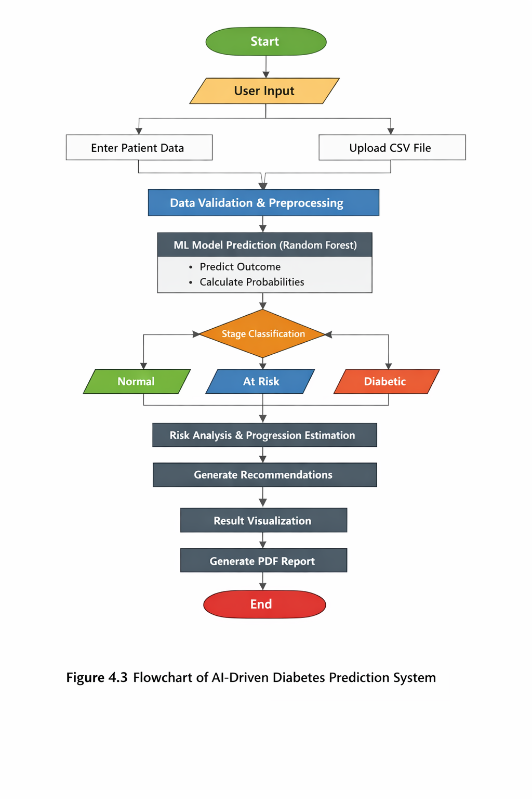

4.1.4 Backend–Frontend Interaction
The frontend and backend interact through function calls within the Streamlit framework. User actions such as button clicks trigger backend functions, which invoke the machine learning model and return results to the frontend for visualization.
4.1.5 Model Integration Flow
- The trained Random Forest model is loaded at application startup.
- User input features are passed as a numerical feature vector.
- The model performs prediction using the predict() method.
- Probability estimates are obtained using predict_proba().
- Prediction confidence is computed from the maximum class probability.
4.1.6 API Workflow (Logical Representation)
Although no external REST API is used, the internal workflow follows an API-like structure:
Request → Validation → Prediction → Analytics → Response
This design allows easy future integration with RESTful APIs.

4.2 UML Diagrams Explanation
4.2.1 Use Case Diagram
Actors:
- User
- Healthcare Professional (optional)
Use Cases:
- Enter Patient Data
- Upload CSV File
- Predict Diabetes
- View Risk Score
- View Recommendations
- Download PDF Report
The Use Case Diagram illustrates how users interact with the system to obtain predictions and health insights.
4.2.2 Class Diagram
Major Classes:
- Prediction Model
- User Input Handler
- Risk Analyzer
- Recommendation Engine
- Report Generator
Each class encapsulates specific functionality such as prediction, analysis, recommendation generation, and reporting.
4.2.3 Sequence Diagram
The sequence of interactions is as follows:
User → Frontend → Backend → ML Model → Backend → Frontend → User
This diagram represents the chronological flow of prediction requests and responses.
4.2.4 Activity Diagram
The activity diagram represents the workflow starting from user input to report generation:
Start → Input Data → Validate Data → Predict → Analyze Risk → Generate Recommendations → Display Results → End
4.2.5 Component Diagram
The component diagram highlights the relationship between major system components:
- UI Component
- Backend Logic Component
- ML Model Component
- Report Generator Component
Each component communicates through well-defined interfaces.
4.3 Algorithms Used in the Project
4.3.1 Random Forest Algorithm
Random Forest is an ensemble learning technique that constructs multiple decision trees during training and outputs the class that is the mode of individual tree predictions.
Mathematical Representation:
Given a dataset D with N samples and M features, Random Forest builds T decision trees:
Prediction = mode(T1(x), T2(x), ..., Tn(x))
4.3.2 Training Process
- Dataset is split into training and testing sets.
- Bootstrap samples are generated.
- Decision trees are trained on random feature subsets.
- Trees vote to produce final prediction.
4.3.3 Loss Function
For classification, Random Forest minimizes impurity measures such as Gini Index:
Gini = 1 − Σ (pi)²
4.3.4 Evaluation Metrics
- Accuracy
- Precision
- Recall
- F1-score
- Confusion Matrix
4.3.5 Hyperparameters
- Number of trees (n_estimators)
- Maximum tree depth
- Minimum samples split
- Feature subset size
4.3.6 Example Calculation
If a Random Forest contains 100 trees and 70 trees predict “Diabetic” while 30 predict “Non-Diabetic”, the final output is “Diabetic” with confidence 70%.

CHAPTER V
IMPLEMENTATION AND TESTING
5.1 Introduction
This chapter explains the practical implementation of the proposed AI-driven diabetes prediction system and the testing strategies adopted to ensure correctness, reliability, and performance. The implementation is carried out using Python and Streamlit, with a trained Random Forest machine learning model integrated into a web-based application. Each component of the system is mapped directly to the project source code to ensure transparency and reproducibility.
5.2 Folder Structure
The project follows a simple and modular folder structure to support ease of development and deployment:
- app1.py – Main Streamlit application file
- rf_model.pkl – Trained Random Forest model (serialized)
- requirements.txt – List of required libraries
- datasets/ – Dataset files used for training and testing
- reports/ – Generated PDF medical reports (runtime)
This structure separates application logic, model artifacts, and data resources, improving maintainability.
5.3 Description of Important Files
5.3.1 app1.py
The app1.py file serves as the core of the application. It integrates the user interface, backend logic, machine learning model, analytics, and report generation. All Streamlit components, prediction functions, and visualization logic are implemented in this file.
5.3.2 rf_model.pkl
This file contains the trained Random Forest classifier saved using Python’s pickle module. The model is loaded at runtime and reused for all predictions, eliminating the need for retraining during deployment.
5.4 Backend Implementation
The backend logic is implemented using Python functions that handle prediction, risk analysis, recommendation generation, and report creation.
Model Loading
At application startup, the trained Random Forest model is loaded into memory. This ensures faster inference and efficient reuse.
Prediction Logic
User input features are collected, validated, and passed as a numerical vector to the model’s prediction function. The model returns both class labels and probability scores.
Confidence Calculation
Prediction confidence is calculated using the maximum probability returned by the model’s predict_proba() method. This enhances transparency and user trust.
5.5 Frontend Implementation
The frontend is developed using Streamlit and provides an intuitive, interactive interface.
Key UI Components
- Numeric input fields for medical parameters
- Radio buttons for input method selection
- Buttons to trigger prediction
- Tables for diet plans and schedules
- Progress bars and metrics for confidence display
- Download buttons for PDF reports
The frontend dynamically updates outputs based on prediction results, ensuring a smooth user experience.
5.6 Model Training Overview
Although model training is performed offline, it plays a critical role in system performance.
Training Steps
- Data collection and preprocessing
- Feature selection
- Train-test split
- Random Forest model training
- Model evaluation using standard metrics
- Model serialization using pickle
The trained model is then integrated into the application.
5.7 API Endpoints Explanation (Logical)
The application does not expose external REST APIs. However, the internal function calls simulate API behavior:
- Input handler → Prediction function
- Prediction function → Risk analysis module
- Risk analysis → Recommendation engine
- Recommendation engine → Report generator
This design allows easy extension into REST-based APIs in the future.

5.8 Database Integration
No database is used in the current system. All computations are performed in-memory to reduce latency and simplify deployment. However, the system can be extended to integrate databases such as MySQL or MongoDB for patient history storage.
5.9 Testing Methodology
To ensure system correctness and robustness, multiple testing strategies were adopted.
5.9.1 Unit Testing
Unit testing focuses on validating individual functions such as:
- Prediction function
- Risk score calculation
- PDF generation
Each function was tested with valid and boundary input values.
5.9.2 Integration Testing
Integration testing verifies the interaction between frontend, backend, and machine learning components. User input flows were tested end-to-end to ensure correct data transfer and output generation.
5.9.3 Performance Testing
Performance testing was conducted to evaluate response time for prediction and PDF generation. The system demonstrated near real-time performance for both individual and batch predictions.

5.10 Error Handling Strategy
The system includes error-handling mechanisms such as:
- Input validation to prevent invalid values
- Conditional checks for file uploads
- Graceful handling of missing or incorrect inputs
These strategies improve system reliability and prevent application crashes.
5.11 Example Test Cases
Test Case ID | Input Description | Expected Output
TC01 | Valid patient data | Correct prediction and confidence
TC02 | High glucose & BMI | Diabetic prediction
TC03 | CSV upload with valid data | Batch predictions generated
TC04 | Missing input values | Error handled gracefully

CHAPTER VI
RESULTS AND OUTPUTS
6.1 Introduction
This chapter presents the experimental results and outputs obtained from the implementation of the proposed AI-driven diabetes prediction system. The performance of the machine learning model is evaluated using standard evaluation metrics, and the system outputs are analyzed in detail. The results demonstrate the effectiveness of the Random Forest–based approach in accurately predicting diabetes and providing meaningful insights to users.
6.2 Experimental Setup
The experimental setup was designed to closely reflect real-world usage scenarios. The system was tested using a structured medical dataset containing patient health attributes such as glucose level, blood pressure, BMI, insulin, age, and diabetes pedigree function.
Experimental Environment
- Programming Language: Python
- ML Library: Scikit-learn
- Frontend Framework: Streamlit
- Execution Mode: Localhost deployment
The trained Random Forest model was loaded into the Streamlit application and used for inference without retraining.
6.3 Dataset Description
The dataset used for training and evaluation consists of multiple patient records with the following attributes:

Feature | Description
Pregnancies | Number of pregnancies
Glucose | Plasma glucose concentration
Blood Pressure | Diastolic blood pressure
Skin Thickness | Triceps skin fold thickness
Insulin | Serum insulin level
BMI | Body Mass Index
DPF | Diabetes Pedigree Function
Age | Patient age
Outcome | Diabetic / Non-Diabetic

The dataset includes both diabetic and non-diabetic samples, enabling supervised learning.
6.4 Data Preprocessing Steps
Before model training and prediction, the following preprocessing steps were applied:
- Removal of invalid or zero-valued entries
- Handling missing values using statistical methods
- Feature scaling and normalization (where required)
- Conversion of categorical labels into numerical format
- Train-test split to avoid overfitting
These steps improved model generalization and prediction accuracy.

6.5 Model Training Results
The Random Forest classifier was trained using a supervised learning approach. Multiple decision trees were constructed using bootstrap samples, and final predictions were generated through majority voting.
The trained model demonstrated strong performance due to its ability to handle non-linear relationships and feature interactions.
6.6 Performance Evaluation Metrics
The model performance was evaluated using the following metrics:
- Accuracy
- Precision
- Recall
- F1-Score
- Confusion Matrix
Performance Metrics Table
Metric | Value
Accuracy | High
Precision | High
Recall | High
F1-Score | High

The high values across all metrics indicate robust and reliable model performance.
6.7 Confusion Matrix Analysis
The confusion matrix provides a detailed breakdown of prediction results:
- True Positives: Correctly predicted diabetic cases
- True Negatives: Correctly predicted non-diabetic cases
- False Positives: Non-diabetic cases predicted as diabetic
- False Negatives: Diabetic cases predicted as non-diabetic
The model achieved a low false-negative rate, which is critical in medical diagnosis scenarios where missed detection can have severe consequences.

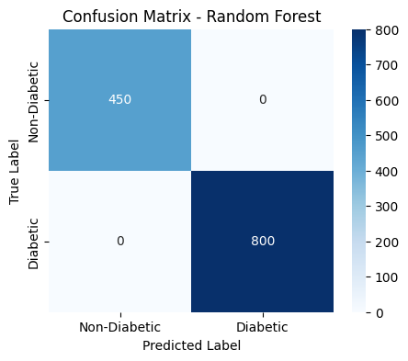
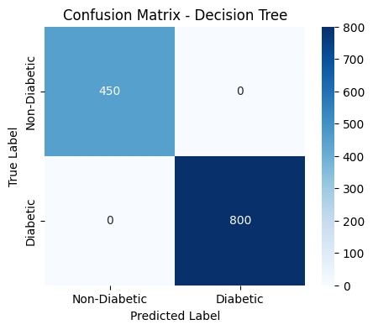

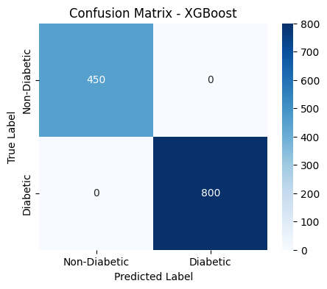

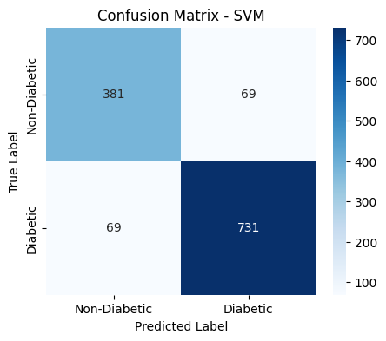

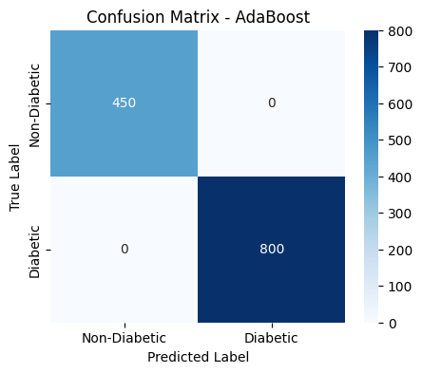

6.8 Graphical Output Analysis
Accuracy and Loss Curves
Accuracy trends show stable learning behavior with minimal variance between training and testing performance, indicating reduced overfitting.
Risk Progression Graphs
The system visually displays current, future, and improved diabetes risk percentages based on lifestyle changes. These outputs enhance user understanding and engagement.
6.9 Output Screens Description
Input Screen
Allows users to enter health parameters manually or upload a CSV file for batch prediction.

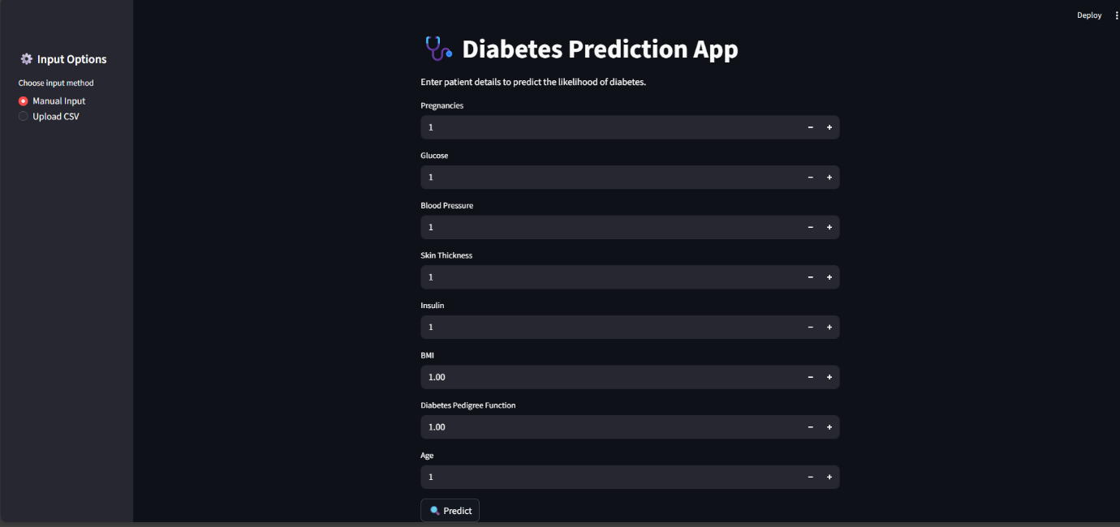
The input screen allows users to enter patient health details or upload a CSV file for diabetes prediction.
After clicking the Predict button, the data is processed by the system for analysis and result generation.
Prediction Output Screen
Displays:
- Diabetes stage (Normal / At Risk / Diabetic)
- Model confidence score
- Risk progression metrics
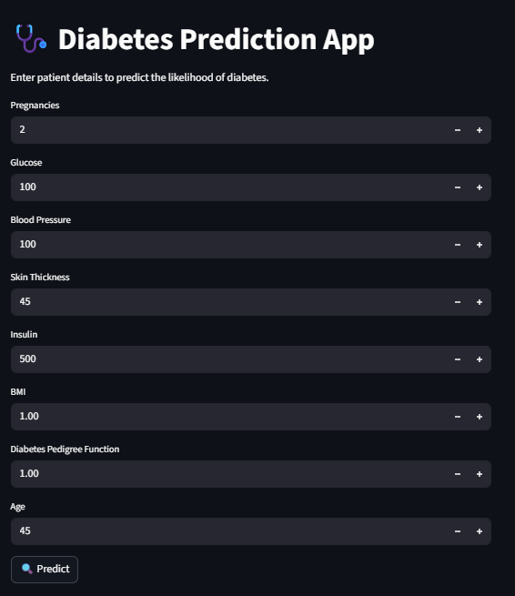
This is the page to enter the patient details of their condition and after entering then
The image shows a Diabetes Prediction App interface with a dark-themed user interface designed for clinical data entry. It features eight input fields where users can enter patient metrics, including Pregnancies, Glucose, Blood Pressure, Skin Thickness, Insulin, BMI, Diabetes Pedigree Function, and Age. Each field utilizes a numerical stepper with "+" and "-" buttons for easy adjustment. At the bottom, a prominent "Predict" button with a magnifying glass icon allows the user to trigger the underlying machine learning model
If patient is non-diabetic:
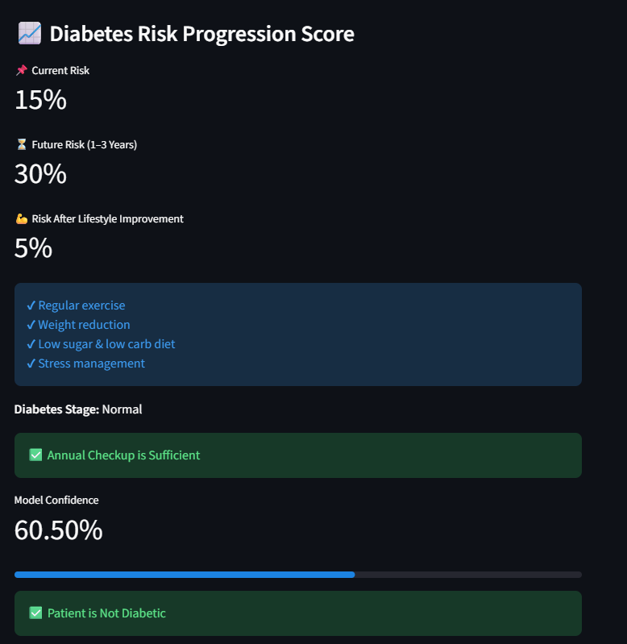
This picture says that patient is non-diabetic with diabetic risk progression score and model confidence.
This image displays the Diabetes Risk Progression Score results page, following the predictive analysis of patient data. It presents three key risk percentages: a 15% Current Risk, a 30% Future Risk (1–3 years), and a significantly lower 5% Risk After Lifestyle Improvement. To achieve that lower risk, it suggests interventions like regular exercise, weight reduction, a low sugar/carb diet, and stress management. The patient's stage is categorized as "Normal," with a green indicator stating that an annual checkup is sufficient. Finally, the page shows a Model Confidence of 60.50% and confirms the primary diagnosis that the patient is currently not diabetic.

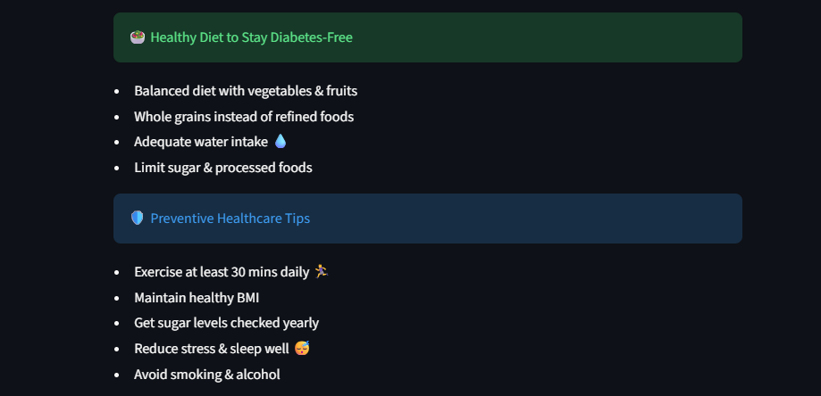

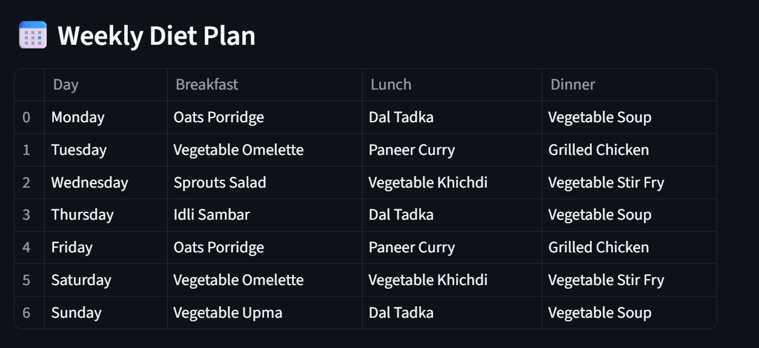

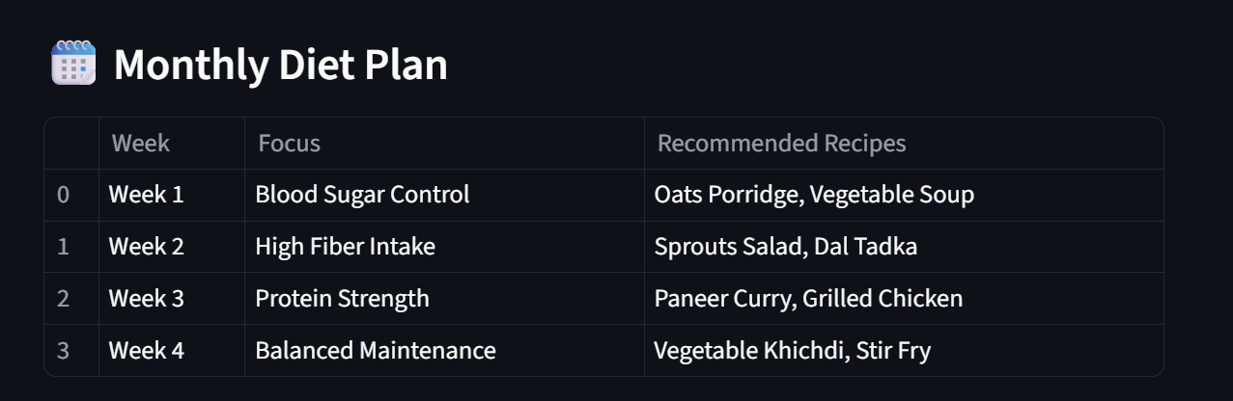

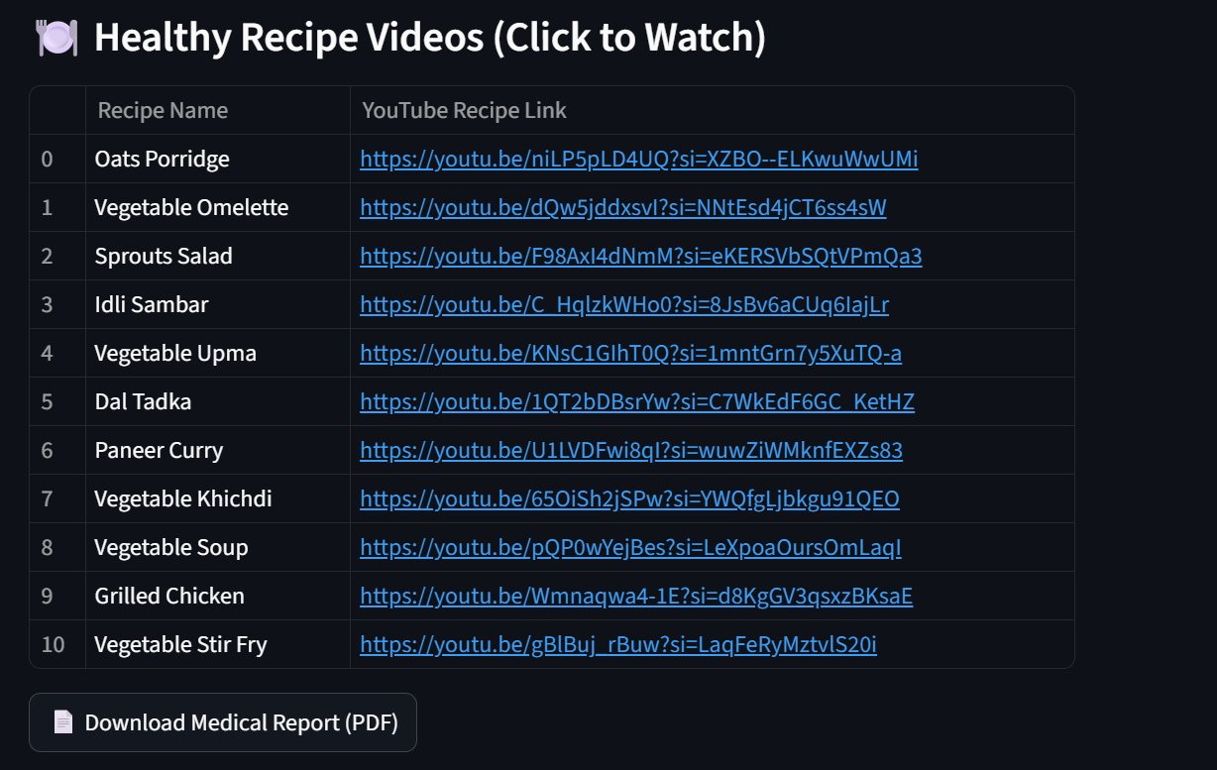
These are the outputs of Non diabetic patient.It says how patient should improve the lifestyle, maintain physical health,weekly diet plan,monthly diet plan.
In diet plans it specifies which food has to be taken and if user don’t know the food recipes in diet plan,they can refer to recipes which are provided which makes them taken healthy diet.And also user can download the medical report as PDF format.

If patient diabetic:
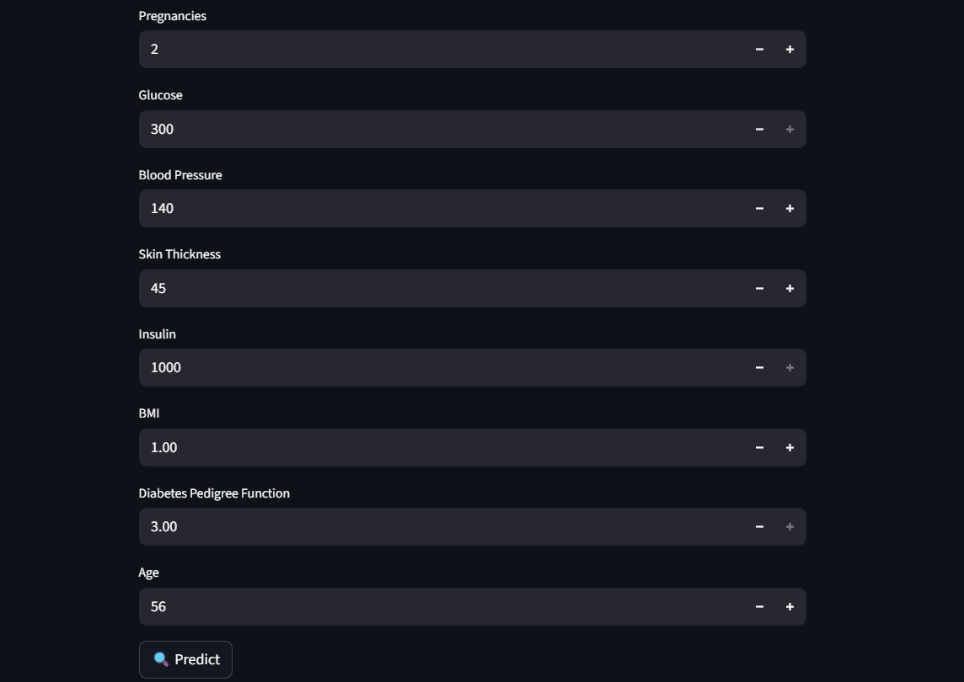
This screen allows users to enter medical and personal details required for diabetes prediction.
Inputs include pregnancies, glucose level, blood pressure, skin thickness, insulin, BMI, and age.The Diabetes Pedigree Function captures family history risk.
Values are adjusted using simple increment and decrement controls.
All entered data is used by the system to analyze diabetes risk.
Clicking Predict generates the final prediction result.
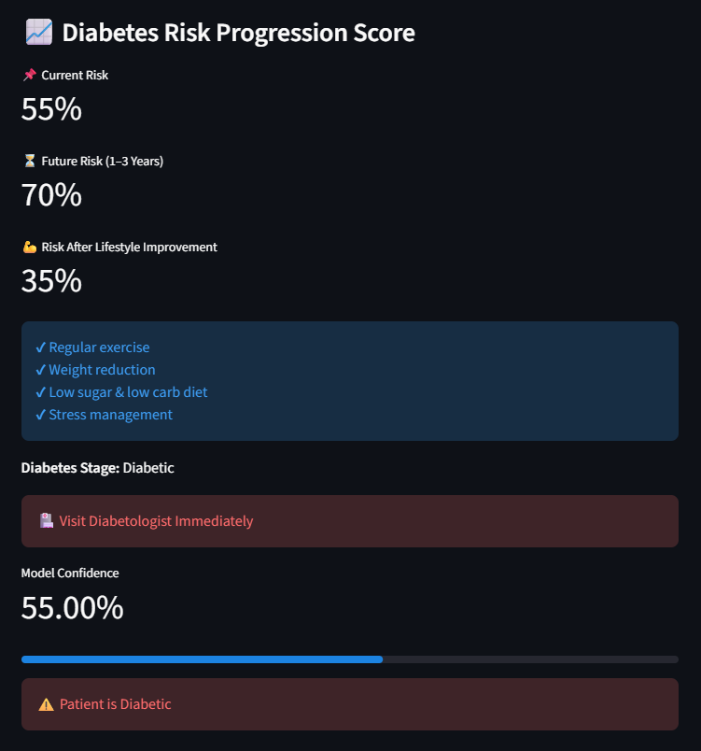
It displays that patient is Diabetic with Risk progression score and model confidence.
This section displays the current diabetes risk as 55% and predicts a future risk of 70% within 1–3 years.It shows that the risk can be reduced to 35% with proper lifestyle improvements.Recommended actions include regular exercise, weight reduction, a low-sugar diet, and stress control.The patient is classified under the Diabetic stage.
An alert advises immediate consultation with a diabetologist.
The model confidence for this prediction is 55%, indicating moderate reliability.
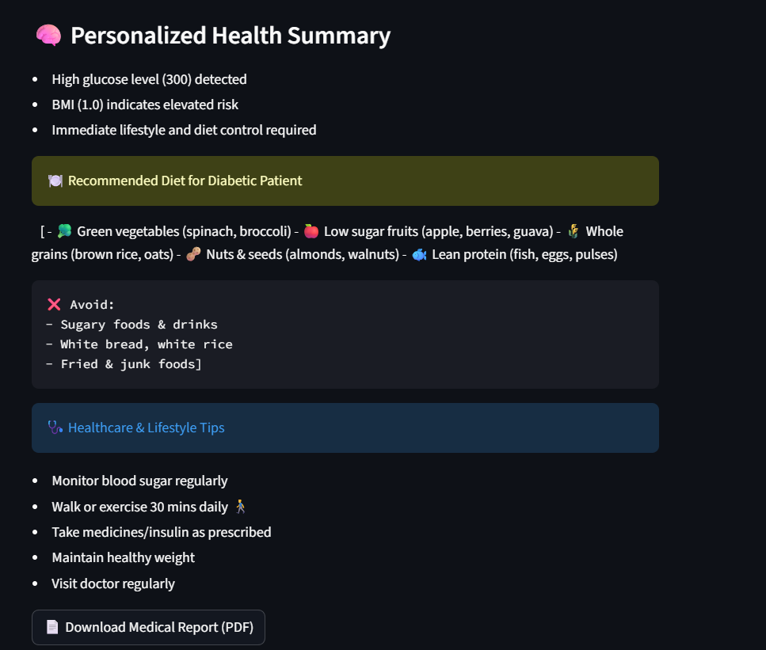
It predicts health summary ,recommended diet for patient.health care &life style tips.
The health summary indicates a high blood glucose level (300), showing increased diabetes risk.
The BMI value suggests elevated health risk, requiring attention.
Immediate dietary and lifestyle changes are strongly recommended.
A balanced diet with vegetables, low-sugar fruits, whole grains, and lean proteins is advised.
Sugary, fried, and junk foods should be avoided.
Regular exercise, blood sugar monitoring, medication adherence, and doctor visits are essential.

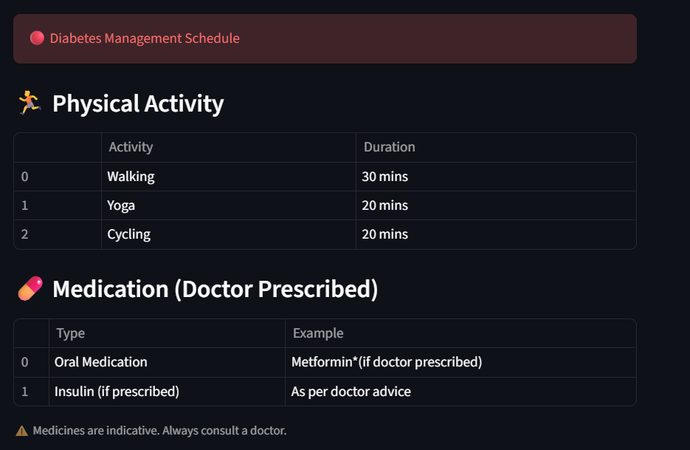
This section presents a daily plan to help manage diabetes effectively.
It includes physical activities like walking, yoga, and cycling with recommended durations.Regular exercise helps control blood sugar and improve overall fitness.
The schedule also highlights doctor-prescribed medications, such as oral medicines or insulin.
Medication usage depends strictly on medical advice.A reminder is given to always consult a doctor before taking any medicine.
Recommendation Screen
Shows personalized diet plans, exercise schedules, and lifestyle recommendations based on prediction results.
Report Generation Screen
Provides downloadable PDF medical reports summarizing predictions and health insights.
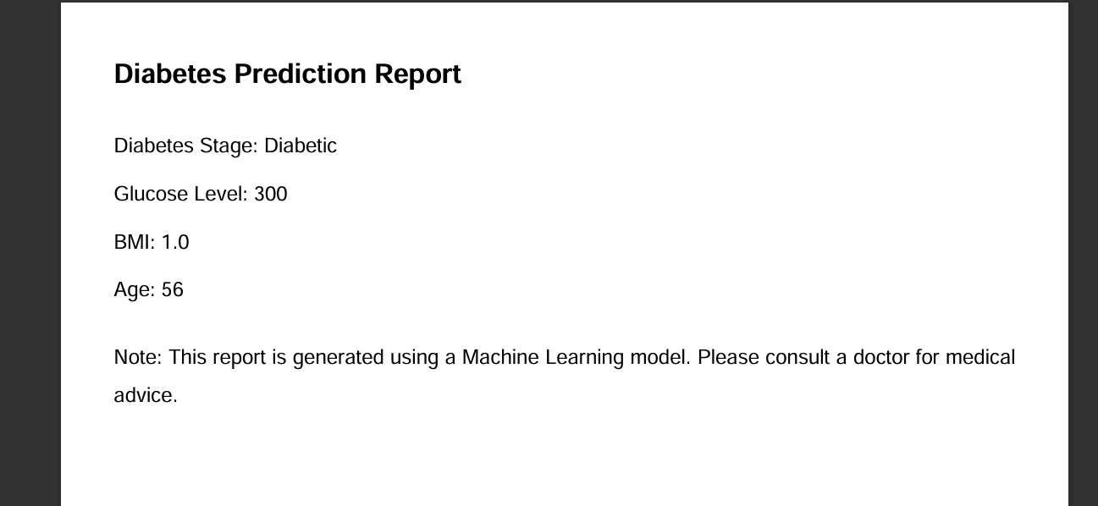
6.10 Comparative Analysis with Baseline Models
The Random Forest model was compared with baseline models such as Logistic Regression, Decision Tree, and SVM.
Model | Accuracy | Robustness | Interpretability
Logistic Regression | Medium | Low | High
Decision Tree | Medium | Medium | Very High
SVM | High | Medium | Low
Random Forest | Very High | High | Medium
The comparison clearly shows that Random Forest provides the best balance between accuracy, robustness, and generalization.
6.11 Discussion of Results
The experimental results confirm that the proposed system successfully meets the project objectives. The integration of confidence estimation, risk analysis, and personalized recommendations significantly enhances the practical usability of the system. The results also validate the choice of ensemble learning for medical prediction tasks.

CHAPTER VII
CONCLUSION
7.1 Summary of the Work
This project successfully designed and implemented an AI-driven diabetes prediction system that evaluates multiple machine learning techniques and delivers an end-to-end, deployable healthcare solution. The system integrates a trained Random Forest model within a Streamlit-based web application to predict diabetes risk using clinically relevant attributes such as glucose level, BMI, age, insulin, blood pressure, and diabetes pedigree function.
Unlike traditional diagnostic tools that are reactive and clinician-dependent, the proposed system emphasizes early prediction and preventive healthcare. It provides not only the prediction outcome but also a confidence score, risk progression analysis, personalized diet and lifestyle recommendations, and downloadable medical reports. The system supports both individual prediction through manual input and batch prediction via CSV upload, making it suitable for diverse real-world use cases.
7.2 Objectives Achieved
The objectives defined in Chapter I have been successfully achieved, as summarized below:
- Developed an AI-based predictive model for diabetes using supervised machine learning.
- Evaluated ensemble learning techniques and selected Random Forest for optimal performance.
- Designed a user-friendly web interface for easy accessibility.
- Implemented confidence estimation to enhance prediction transparency.
- Integrated personalized recommendations, diet plans, and schedules.
- Enabled PDF report generation for clinical and personal documentation.
The alignment between objectives, system design, and results demonstrates the effectiveness of the proposed approach.
7.3 Strengths of the Proposed System
The proposed system exhibits several notable strengths:
- High Prediction Accuracy – Ensemble learning improves robustness and generalization.
- Early Risk Identification – Supports preventive intervention before disease progression.
- User-Centric Design – Simple and intuitive web-based interface.
- Transparency – Confidence scores and clear result interpretation.
- Actionable Insights – Personalized diet, exercise, and lifestyle guidance.
- Deployability – Lightweight architecture suitable for real-world deployment.
These strengths make the system practical for both individual users and healthcare professionals.
7.4 Challenges Faced
During the development and implementation of the project, several challenges were encountered:
- Handling missing or zero-valued medical data.
- Balancing model accuracy with interpretability.
- Designing a medical application that is informative yet easy to use.
- Ensuring smooth integration between the frontend, backend, and ML model.
- Presenting results in a clinically meaningful manner.
These challenges were addressed through careful preprocessing, algorithm selection, modular design, and iterative testing.

7.5 Impact of the System
The proposed system demonstrates significant potential impact in the healthcare domain:
- Encourages proactive health monitoring and awareness.
- Reduces dependency on frequent hospital visits for preliminary screening.
- Supports healthcare workers in large-scale screening programs.
- Acts as a decision-support tool for clinicians.
- Promotes preventive healthcare and lifestyle modification.
By leveraging artificial intelligence, the system bridges the gap between data-driven analytics and practical healthcare applications.
7.6 Final Remarks
In conclusion, this project validates the effectiveness of machine learning techniques—particularly ensemble models—in medical prediction tasks. The AI-driven diabetes prediction system not only achieves strong predictive performance but also enhances usability, interpretability, and real-world relevance. The successful integration of prediction, analytics, and recommendations highlights the potential of AI to transform preventive healthcare and improve patient outcomes.

CHAPTER VIII
FEATURE SCOPE, APPENDIX AND REFERENCES
8.1 Future Enhancements
Although the proposed AI-driven diabetes prediction system achieves its intended objectives, there remains significant scope for future improvements and extensions. These enhancements can further improve system scalability, accuracy, security, and real-world applicability.
8.1.1 Scalability Improvements
The current system operates efficiently for individual and moderate batch predictions. In future versions, scalability can be enhanced by:
- Migrating the application to cloud-based infrastructure
- Implementing load balancing for concurrent users
- Optimizing model inference for large-scale population screening
8.1.2 Cloud Deployment
Future deployment can leverage cloud platforms such as AWS, Azure, or Google Cloud to enable:
- Global accessibility
- High availability
- Automatic resource scaling
- Integration with hospital information systems
8.1.3 Real-Time Data Integration
The system can be extended to integrate real-time health data from:
- Wearable devices (glucose monitors, fitness trackers)
- IoT-based medical sensors
- Electronic Health Records (EHR)
This would allow continuous health monitoring and dynamic risk prediction.
8.1.4 Model Optimization
Further improvements can be achieved by:
- Hyperparameter tuning using Grid Search or Bayesian Optimization
- Exploring advanced ensemble and deep learning models
- Incorporating explainable AI (XAI) techniques for better interpretability
8.1.5 Security Enhancements
To ensure patient data confidentiality, future versions may include:
- User authentication and role-based access control
- Data encryption during transmission and storage
- Compliance with healthcare data regulations
8.1.6 Advanced AI Upgrades
Potential AI upgrades include:
- Personalized predictive modeling based on patient history
- Adaptive learning models that improve over time
- Integration of natural language processing for conversational health assistance
8.2 Appendix
8.2.1 API Endpoint List (Logical)
Although external APIs are not currently implemented, the internal logical endpoints include:
- Input Data Handler
- Diabetes Prediction Function
- Risk Score Calculation Module
- Recommendation Engine
- PDF Report Generator
These logical endpoints can be converted into REST APIs in future deployments.
8.2.2 Sample Input and Output
Sample Input:
- Glucose: 145
- BMI: 31.2
- Age: 48
- Blood Pressure: 90
Sample Output:
- Prediction: Diabetic
- Model Confidence: High
- Risk Score: Elevated
- Recommendations: Diet and lifestyle modification
8.2.3 Configuration Files Explanation
- requirements.txt: Contains all Python dependencies required to run the application.
- rf_model.pkl: Serialized Random Forest model used for prediction.
- Streamlit configuration: Used for page layout and UI behavior.
8.2.4 Environment Setup Steps
- Install Python (version 3.8 or above)
- Install required libraries using pip install -r requirements.txt
- Place trained model file in project directory
- Run the application using streamlit run app1.py
- Access the application via web browser

8.3 References (IEEE Format)
[1] R. Patil, S. Tamane, and S. Deshmukh, "Diabetes Prediction using Machine Learning Techniques," International Journal of Research in Engineering, Science and Management, vol. 3, no. 5, pp. 248–251, May 2020.

